**Denny’s Vocabulary App (Name TBD)**

The purpose of this app is to assist my English students with their vocabulary learning. For most of my students, the number one obstacle to their success is vocabulary knowledge. Currently, I assign them a variety of resources, both online and offline, in order to help them develop a personal dictionary, which includes new words, definitions, and sentences which help them to remember those words.

The purpose of this app is to replace the offline notebook idea and consolidate all of these resources (dictionaries, other vocab apps) into one online service. Also, teachers will be able to monitor students’ progress.

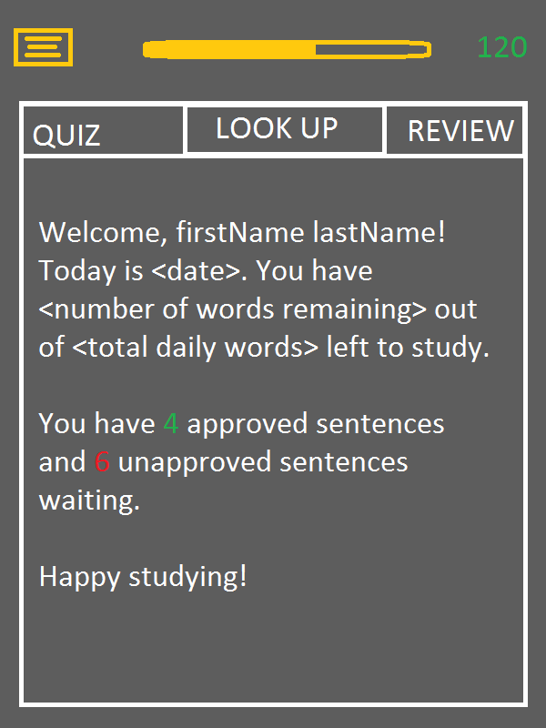This is what the first screen looks like. The user will have to set up an account using their email address. They insert their name as well. They will also input their reason for studying (IELTS, SAT, GRE, General English, Other). They can also optionally input their teacher’s account so that the teacher can review their words.

The student and teacher will set a target number of words per day, and the student must learn this number of words per day or their teacher will notice they are falling behind. The number of words can be seen in the center top as a progress bar, and the top left number is the number of words learned so far.

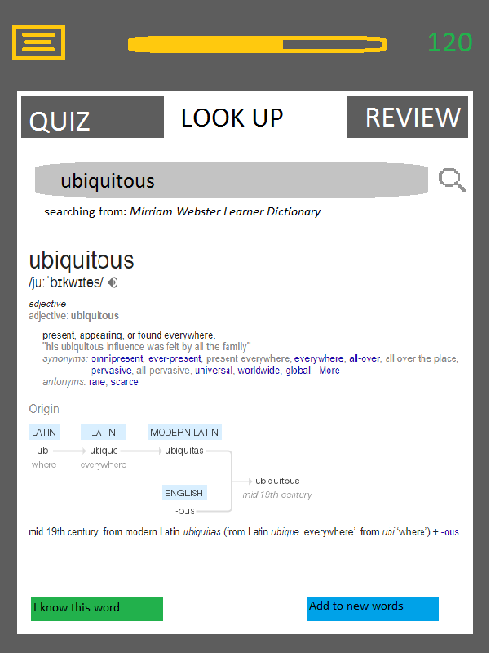This is the look up tab, where the user can look up a new word. They can search the word using the search bar. There are a number of dictionaries available to be searched, which is displayed under the search bar. The results display the word, IPA pronunciation, a button to play a sound clip of the word, type of word, definition, a sentence containing the word, and synonyms. It should also contain word roots.

If the user presses “add this to new words” this new word will be added to a list of unlearned words.

If they press “I know this word” they will be prompted to write a sentence containing the word, which will then be submitted for teacher approval.

In the quiz tab, the user goes through words that they have added to their “new words” list. The user will be prompted with one word, and 5 synonyms. If they choose the right one, they will be prompted to write a sentence using the word, which will then be submitted for teacher approval.

If they choose the wrong word, it will be shuffled back into the new words list. Alternatively they can also press the I’m not sure button which will have the same outcome. 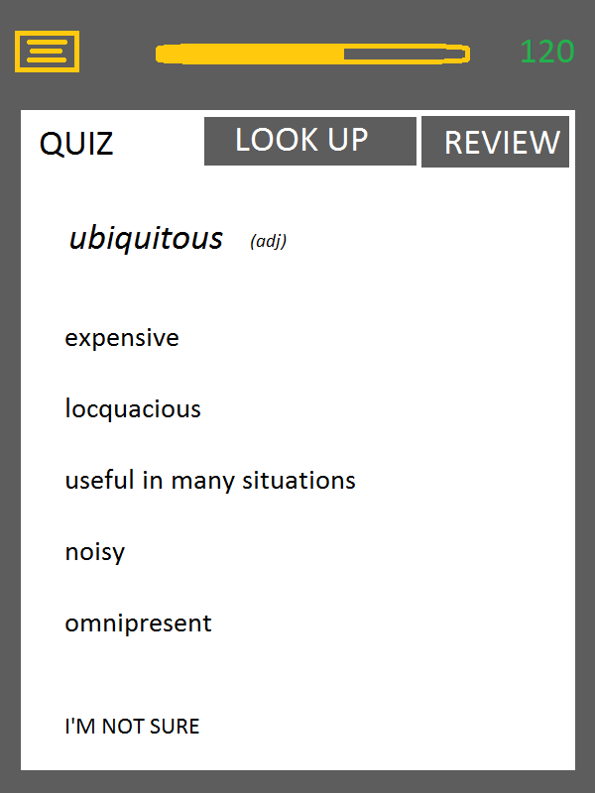

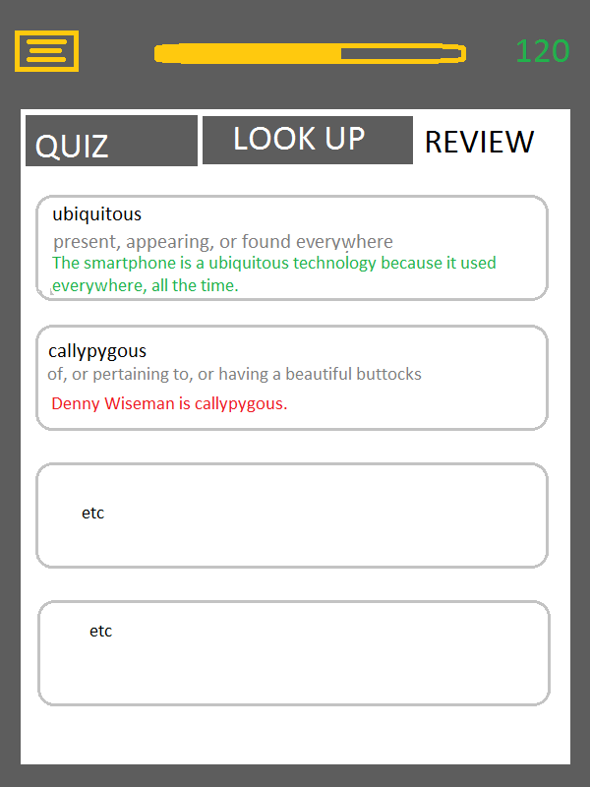

These are words that have been learned by the user. Each card contains the word, the definition, and the student produced sentence. If the sentence is green, it has been approved by the teacher. If it is still red it has been rejected (grey or something will be pending approval).

The cards can be sorted in the following ways: alphabetical, by date learned, word type, approved/rejected/pending approval.

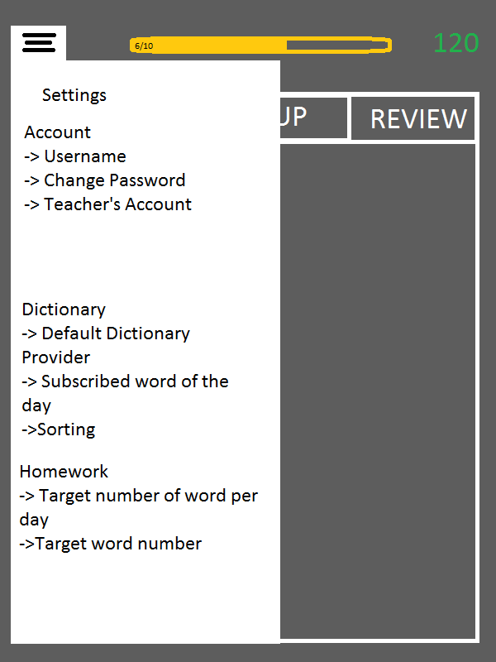

Settings page